一、对dicom文件属性格式的研究：

https://www.cnblogs.com/XDU-Lakers/p/9863114.html

https://www.dicomlibrary.com/dicom/dicom-tags/

dicom文件包含了文件头和数据集两部分。

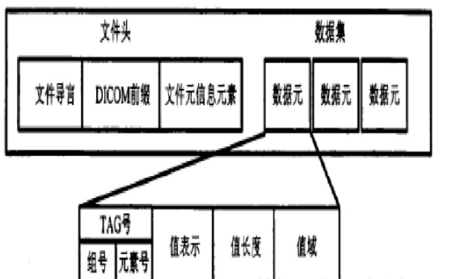

文件头：文件导言，DICOM前缀，文件元信息元素。

数据集：包含多个数据元。

数据元：TAG号（组号，元素号），值表示（VR），值长度(VL)，值域(VF，其实就是数据值)。

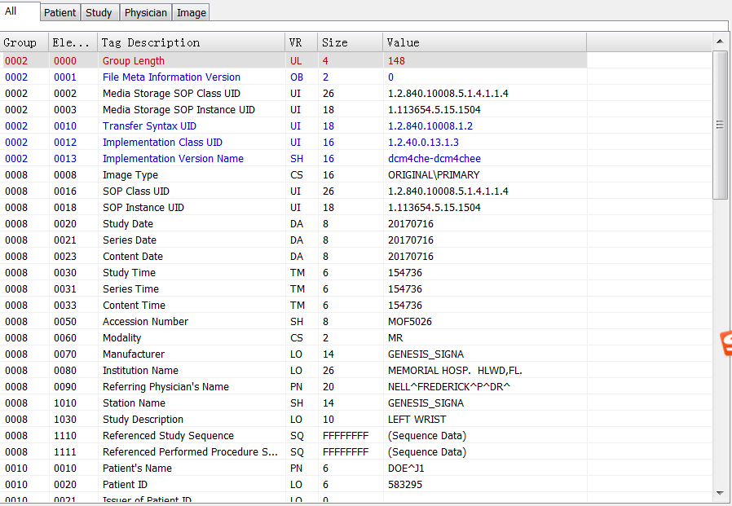

如

Tag：(0002,0002)

Type：UI

Value：1.2.840.10008.5.1.4.1.1.2

Name：Media Storage SOP Class UID

TAG：有四大类（Patient，Study，Series，Image），这个跟组号无关。

值表示：数据类型，其实也就是Type。

在Viewer可以看到某个dcm文件不同Tag的值，如：

Patient

Patient's Name: DOE, J1

Patient ID: 583295

Patient's Sex: Male

Station

Manufacturer: GENESIS_SIGNA

Station Name: GENESIS_SIGNA

Study

Study Instance UID: 1.113654.3.13.1026

Study Date: 2017-7-16

Study Time: 15:47:36

Study ID: RP1026

Accession Number: MOF5026

Study Description: LEFT WRIST

Series

Series Instance UID: 1.113654.5.14.1035

Series Date: 2017-7-16

Series Time: 15:47:36

Series Number: 107

Modality: MR

Referring Physician's Name: NELL, FREDERICK P, DR

Institution Name: MEMORIAL HOSP. HLWD,FL.

DICOM Object

SOP Instance UID: 1.113654.5.15.1508

Image Type: ORIGINAL\PRIMARY

Transfer Syntax UID: 1.2.840.10008.1.2

Instance Number: 13

Photometric Interpretation: MONOCHROME2

Samples per Pixel: 1

Pixel Representation: 0

Columns: 256

Rows: 256

Bits Allocated: 16

Bits Stored: 16

Image Plane

Pixel Spacing: 0.234375, 0.234375

Slice Location: -18.007843

Slice Thickness: 2.0

Image Position (Patient): 65.359375, 18.007843, 23.554688

Image Orientation (Patient): 1.0, 0.0, 0.0, 0.0, 0.0, -1.0

(0002,0001) [OB] FileMetaInformationVersion: binary data

(0002,0002) [UI] MediaStorageSOPClassUID: 1.2.840.10008.5.1.4.1.1.4

(0002,0003) [UI] MediaStorageSOPInstanceUID: 1.113654.5.15.1511

(0002,0010) [UI] TransferSyntaxUID: 1.2.840.10008.1.2

(0002,0012) [UI] ImplementationClassUID: 1.2.40.0.13.1.3

(0002,0013) [SH] ImplementationVersionName: dcm4che-dcm4chee

(0008,0008) [CS] ImageType: ORIGINAL\PRIMARY

(0008,0016) [UI] SOPClassUID: 1.2.840.10008.5.1.4.1.1.4

(0008,0018) [UI] SOPInstanceUID: 1.113654.5.15.1511

(0008,0020) [DA] StudyDate: 20170716

(0008,0021) [DA] SeriesDate: 20170716

(0008,0023) [DA] ContentDate: 20170716

(0008,0030) [TM] StudyTime: 154736

(0008,0031) [TM] SeriesTime: 154736

(0008,0033) [TM] ContentTime: 154736

(0008,0050) [SH] AccessionNumber: MOF5026

(0008,0060) [CS] Modality: MR

(0008,0070) [LO] Manufacturer: GENESIS_SIGNA

(0008,0080) [LO] InstitutionName: MEMORIAL HOSP. HLWD,FL.

(0008,0090) [PN] ReferringPhysicianName: NELL^FREDERICK^P^DR^

(0008,1010) [SH] StationName: GENESIS_SIGNA

(0008,1030) [LO] StudyDescription: LEFT WRIST

(0008,1110) [SQ] ReferencedStudySequence: 1 item

--> ITEM #1

-->(0008,1150) [UI] ReferencedSOPClassUID: 1.2.840.10008.3.1.2.3.1

-->(0008,1155) [UI] ReferencedSOPInstanceUID: 1.113654.3.13.1026

(0008,1111) [SQ] ReferencedPerformedProcedureStepSequence: 1 item

--> ITEM #1

-->(0008,1150) [UI] ReferencedSOPClassUID: 1.2.840.10008.3.1.2.3.3

-->(0008,1155) [UI] ReferencedSOPInstanceUID: 1.113654.5.22.1035

(0010,0010) [PN] PatientName: DOE^J1

(0010,0020) [LO] PatientID: 583295

(0010,0021) [LO] IssuerOfPatientID:

(0010,0030) [DA] PatientBirthDate:

(0010,0040) [CS] PatientSex: M

(0010,1010) [AS] PatientAge:

(0010,1030) [DS] PatientWeight: 0

(0018,0010) [LO] ContrastBolusAgent:

(0018,0020) [CS] ScanningSequence: GR

(0018,0021) [CS] SequenceVariant:

(0018,0022) [CS] ScanOptions:

(0018,0023) [CS] MRAcquisitionType:

(0018,0050) [DS] SliceThickness: 2

(0018,0080) [DS] RepetitionTime: 235

(0018,0081) [DS] EchoTime: 11

(0018,0082) [DS] InversionTime: 0

(0018,0087) [DS] MagneticFieldStrength: 15015

(0018,0091) [IS] EchoTrainLength:

(0018,1030) [LO] ProtocolName: IHE Protocol 1

(0018,1060) [DS] TriggerTime: 0.000000

(0018,5100) [CS] PatientPosition: HFP

(0020,000D) [UI] StudyInstanceUID: 1.113654.3.13.1026

(0020,000E) [UI] SeriesInstanceUID: 1.113654.5.14.1035

(0020,0010) [SH] StudyID: RP1026

(0020,0011) [IS] SeriesNumber: 107

(0020,0012) [IS] AcquisitionNumber: 0

(0020,0013) [IS] InstanceNumber: 16

(0020,0020) [CS] PatientOrientation: L\F

(0020,0032) [DS] ImagePositionPatient: 65.359375\24.007843\23.554688

(0020,0037) [DS] ImageOrientationPatient: 1\0\0\0\0\-1

(0020,0052) [UI] FrameOfReferenceUID: 1.2.840.113619.2.1.4990.3319950539.7.718378955.1080680448

(0020,0060) [CS] Laterality:

(0020,1040) [LO] PositionReferenceIndicator: WR

(0020,1041) [DS] SliceLocation: -24.007843

(0020,4000) [LT] ImageComments:

(0028,0002) [US] SamplesPerPixel: 1

(0028,0004) [CS] PhotometricInterpretation: MONOCHROME2

(0028,0010) [US] Rows: 256

(0028,0011) [US] Columns: 256

(0028,0030) [DS] PixelSpacing: 0.234375\0.234375

(0028,0100) [US] BitsAllocated: 16

(0028,0101) [US] BitsStored: 16

(0028,0102) [US] HighBit: 15

(0028,0103) [US] PixelRepresentation: 0

(0028,1050) [DS] WindowCenter: 844

(0028,1051) [DS] WindowWidth: 2677

(0028,1052) [DS] RescaleIntercept: 0

(0028,1053) [DS] RescaleSlope: 1

(0040,0244) [DA] PerformedProcedureStepStartDate: 20170716

(0040,0245) [TM] PerformedProcedureStepStartTime: 154736

(0040,0253) [SH] PerformedProcedureStepID: PPSID1035

(0040,0254) [LO] PerformedProcedureStepDescription:

(0040,0275) [SQ] RequestAttributesSequence: 1 item

--> ITEM #1

-->(0040,0007) [LO] ScheduledProcedureStepDescription: P1 10

-->(0040,0008) [SQ] ScheduledProtocolCodeSequence: 1 item

----> ITEM #1

---->(0008,0100) [SH] CodeValue: X1_A1

---->(0008,0102) [SH] CodingSchemeDesignator: DSS_MESA

---->(0008,0104) [LO] CodeMeaning: SP Action Item X1_A1

-->(0040,0009) [SH] ScheduledProcedureStepID: SPS2032

-->(0040,1001) [SH] RequestedProcedureID: RP1026

(7FE0,0010) [OW] PixelData: binary data

个人理解：

1.

不同的dicom文件不但对于同一个Tag会有不同的值，可能还会有不同的Tag，这些Tag也称为Attributes。

二、关于SOPInstanceUID、TransferSyntaxUID、SOPClassUID和Presentation Context：

http://blog.sina.com.cn/s/blog_6cb7b8d701011qox.html

<https://blog.csdn.net/u014738683/article/details/54573611>

SOPInstanceUID本人看到的是每个dcm文件都有不同的UID。

不同的DICOM服务用于不同的目的，客户端（SCU）会向服务端（SCP）发送其希望从服务端获得的服务，而服务端会查看其提供的各项服务是否是客户端期望的来决定是否提供。鉴于以上原因，客户端（SCU）会向服务端发送一系列长度小于128的被称为描述上下文（Presentation Contexts）的消息列表，每一个描述上下文代表一种客户端期望的服务。客户端用DICOM标识符来标识每种服务，即SOP Class UID（Service Object Pair Class Unique Identifier）。在连接上下文中，被发送的SOP Class 也被叫做抽象语义Abstract Syntax（一定要与Transfer Syntaxes中的Syntaxes区分，In the context of association negotiation, the field where the SOP class is sent is also called "Abstract Syntax".），因此Abstract Syntax就是SOP Class UID的同义词。在传输SOP Class UID（即Abstract Syntax）的同时，会发送与该服务对应的编码格式，即Transfer Syntaxes。以乳腺检查的X光片为例，通常乳腺X光片很大，需要进行压缩。客户端在向服务端发送上下文信息时会提供给服务端一种乳腺X光片的压缩方式，例如JPEG2000，同时也会提供一种被大多数图像传输服务端接受的非压缩方式。

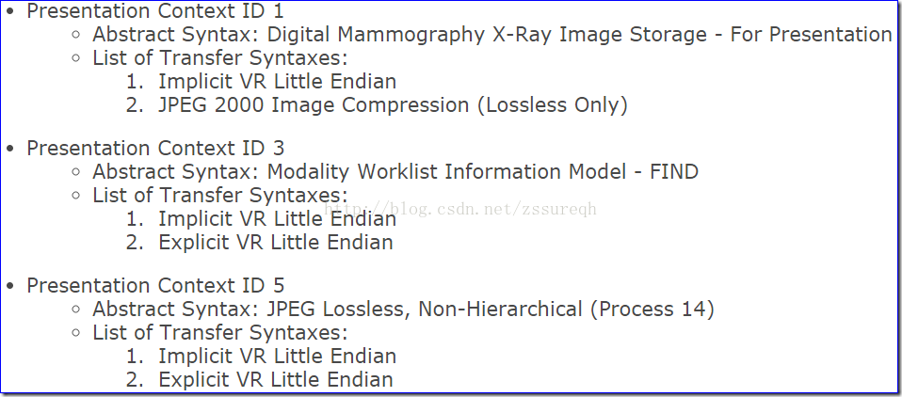

本PACS用了openldap，一个SOPClassUID在openldap会对应一个dn(Distinguished Name (LDAP))，而在openldap导入的default-config.ldif文件会有如下之类的信息：

dn: cn=X-Ray Radiation Dose SR Storage SCP,dicomAETitle=DCM4CHEE,dicomDeviceName=dcm4chee-arc,cn=Devices,cn=DICOM Configuration,dc=dcm4che,dc=org

dicomSOPClass: 1.2.840.10008.5.1.4.1.1.88.67

dicomTransferRole: SCP

dicomTransferSyntax: 1.2.840.10008.1.2

dicomTransferSyntax: 1.2.840.10008.1.2.1

dicomTransferSyntax: 1.2.840.10008.1.2.1.99

objectClass: dicomTransferCapability

objectClass: dcmTransferCapability

cn: X-Ray Radiation Dose SR Storage SCP

对于我们的测试图像所对应的那个SOPClassUID，在dcm文件具有属性：

(0002,0002) [UI] MediaStorageSOPClassUID: 1.2.840.10008.5.1.4.1.1.4

(0002,0010) [UI] TransferSyntaxUID: 1.2.840.10008.1.2

在dcm4chee的default-config.ldif可以找到对应的：

dn: cn=MR Image Storage SCP,dicomAETitle=DCM4CHEE,dicomDeviceName=dcm4chee-arc,cn=Devices,cn=DICOM Configuration,dc=dcm4che,dc=org

dicomSOPClass: 1.2.840.10008.5.1.4.1.1.4

dicomTransferRole: SCP

dicomTransferSyntax: 1.2.840.10008.1.2

dicomTransferSyntax: 1.2.840.10008.1.2.1

dicomTransferSyntax: 1.2.840.10008.1.2.4.50

dicomTransferSyntax: 1.2.840.10008.1.2.4.51

dicomTransferSyntax: 1.2.840.10008.1.2.4.70

dicomTransferSyntax: 1.2.840.10008.1.2.4.57

dicomTransferSyntax: 1.2.840.10008.1.2.4.80

dicomTransferSyntax: 1.2.840.10008.1.2.4.81

dicomTransferSyntax: 1.2.840.10008.1.2.4.90

dicomTransferSyntax: 1.2.840.10008.1.2.4.91

dicomTransferSyntax: 1.2.840.10008.1.2.5

objectClass: dicomTransferCapability

objectClass: dcmTransferCapability

cn: MR Image Storage SCP

对于java这边所对应的文件如：./dcm4che-assembly/src/etc/storescu/rel-sop-classes.properties会包含这些信息。

个人理解：

1.

Presentation Context是请求方需要给接受方提供的信息，会被用于AE间建立连接，接受方会根据这份信息选择接受或不接受连接。

遗留问题：

1.

有一点不确定的是，Presentation Context会提供Abtract Syntax和Transfer Syntax，而这些信息是建立连接的时候交流的还是被写到了dcm文件然后接收方再读取文件的Tag然后再选择是否接受服务的，毕竟本人看到了dcm文件里有相关的Tag如SOPClassUID和TransferSyntaxUID。

答：

<https://stackoverflow.com/questions/1957005/dicom-c-get-vs-c-move>

有三个依据，一是官方文档(A.3.5 Basics of DICOM Communication)对dicom流程的简述，另外一个是上面的回答。从此看出我认为Presentation Context是用于建立连接的而连接建立完成后才传输数据，即便dcm包的tag也会提供类似的信息。

同时<https://otechimg.com/_getDoc.cfm?id=105&started=1>也有一句话：

What is the benefit of negotiating a connection prior to the actual information

exchange?

2.

TransferSyntax的具体作用是什么，是否就是用于解码dcm格式文件，或者说只是用于解码dcm格式文件的其中某些部分。

三、关于storescp和storescu的作用：

http://blog.sina.com.cn/s/blog_bd16551a01016q0x.html

storescu的作用是把影像传给dicom服务器，命令类似于：storescu.exe 127.0.0.1 104 C:\DICOM\Source\CT1\CT.dcm storescu放置在客户端，storescp是用于接收dicom影像并进行保存的服务端程序，放置在服务端。

个人理解：

1.

以后看到SCU就是dicom服务请求者，SCP就是dicom服务提供者。

2.

两个AE之间的交流，在dicom协议当中，服务请求者不只是简单地把文件传过去就行了，还需要遵从dicom协议还规定的节点之间的交流方式，因此客户端也需要有相应的代码，dicom协议可以遵循c/s架构或b/s架构。